1. Define your target market: Target market is the European Union.
2. Identify your market segment: Market segment is parents or guardians of young children who are interested in educational toys and STEM (science, technology, engineering, and math) education.
3. Identify the user: The children, that correspond to 80 million

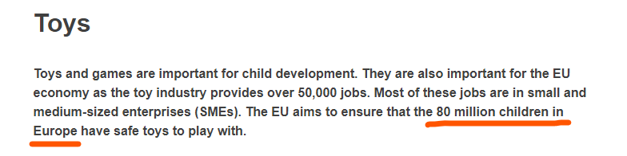

1. Estimate the number of potential customers:

According to Eurostat, the population of the European Union in 2020 was approximately 447 million. Knowing that the percentagem of people in the EU comprised from the age of 20-49 (Expected parenting age) is 42% this leads to a total of 187 million potential parents. Assuming that parents or guardians of young children make up about 50% that number, we can estimate that the potential customer base for your product is approximately 90 million.

1. Calculate the market size: Assuming that the price of your product is €25, and that you can capture 5% of the potential customer base, the market size would be:

Market size = (Potential customers x Average price) x Market share

Market size = (90 million x €25) x 0.05 = €112 million

1. Consider market growth: The market for educational toys and STEM education is expected to grow in the European Union, driven by increasing interest in technology and science among parents and children.